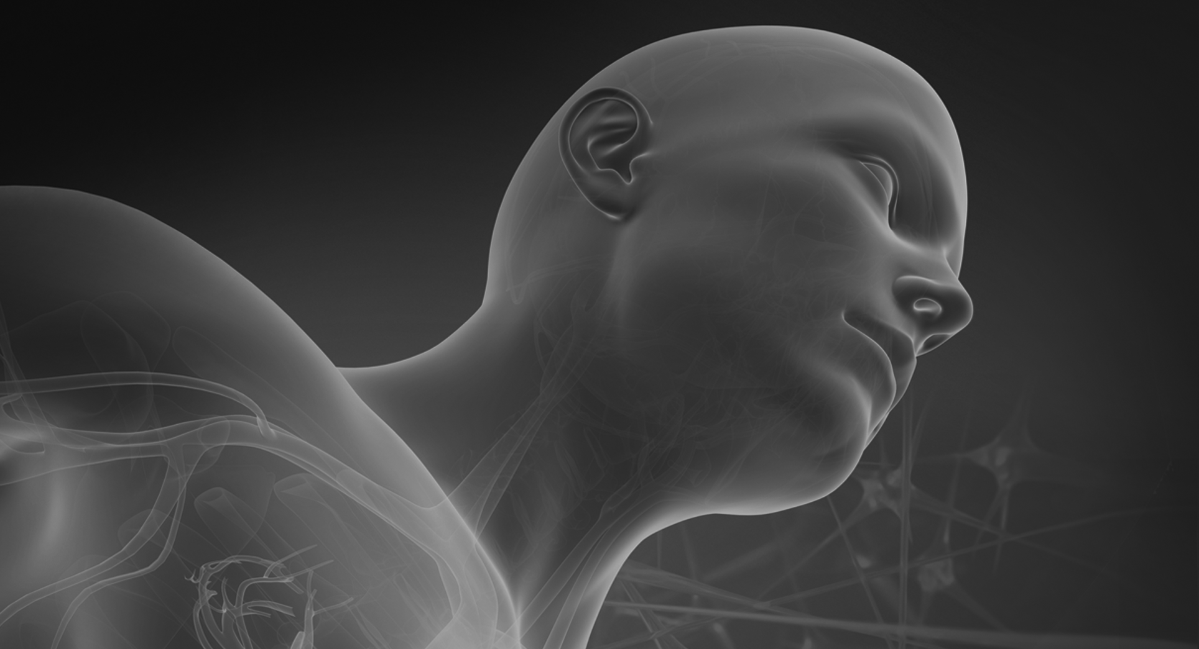
Chapter 1

Introduction to the Structural Units
Answers to Textbook Exercises
Review Questions
Select the letter of the choice that best completes the statement.
1. The study of the size and shape of the heart is called
b. anatomy.
2. Physiology is the study of
c. the function of the lungs.
3. The anatomical position is described as
a. body erect, arms at the side, palms forward.
4. A plane that divides the body into right and left parts is a
c. sagittal plane.
5. If a person is complaining of pain that may indicate appendicitis, the pain would be located in the
a. left lower quadrant.
6. The heart is described as superior to the diaphragm because it is
c. above the diaphragm.
7. The brain and the spinal cord are located in the
d. dorsal cavity.
8. The epigastric region of the abdominal area is located
c. just below the sternum.
9. Shivering to keep the body warm is an example of
d. homeostasis.
10. The formation and release of hormones from a cell or structure is called
d. secretion.
Fill in the Blanks
1. The standard used for measurement in science is the metric system.
2. Danny, age 6, fell off his skateboard and had a 1.5-inch abrasion on his left arm. This is the same as 3.75 centimeters.
3. Two teaspoonfuls of cough medicine equal 10 milliliters of cough medicine.
4. The doctor orders 2 grams of penicillin to be divided into 4 doses over 24 hours. This means the average single dose will be 500 milligrams.
5. A kilogram is equal to 2.2 pounds.
Matching
Match each term in Column I with its correct description in Column II.
Column I Column II
c 1. catabolism a. balanced cellular environment
e 2. pelvic cavity b. constructive chemical processes that use food to build the complex materials of the body
g 3. pericardial cavity c. useful breakdown of food materials resulting in the release of
energy
b 4. anabolism d. contained within the oral cavity
f 5. abdominal cavity e. cavity in which the reproductive organs, urinary bladder, and lower part of the large intestine are located
j 6. diaphragm f. cavity in which the stomach, liver, gallbladder, pancreas, spleen,
small intestine, appendix, and part of the large intestine are located
a 7. homeostasis g. cavity containing the heart
h 8. tissue h. a group of cells that together perform a particular job
k 9. kidneys i. portion of the dorsal cavity containing the brain
d 10. teeth and tongue j. divides the ventral cavity into two regions
i 11. cranial cavity k. structure located behind the abdominal cavity
l 12. organ system l. organs grouped together because they have a related function
m 13. life function m. an activity that a living thing performs to help it live and grow

Applying Theory to Practice
1. In each of the examples below, choose the term that correctly describes the human body according to anatomical position.
a. In the anatomical position, the palms are forward or backward.
b. The liver is superior or inferior to the diaphragm.
c. The hand is proximal or distal to the elbow.
d. The shoulder blade is on the anterior or posterior part of the body.
e. Cranial refers to the head or tail end of the body.
f. The coronal plane divides the body into front and back or right and left sections.
g. The arms are located on the medial or lateral side of the body.
h. The transverse plane divides the body into superior and inferior or anterior and posterior parts.
2. Describe the following to a physician using the correct anatomical term.
a. An appendectomy scar is located in the right iliac or inguinal area of the abdominal pelvic region or right lower quadrant of the abdomen.
b. A wound on the front of the leg is on the anterior surface of the lower limb.
c. The end of the spine is referred to as the caudal area.
d. A pain near the breastbone is located in the mediastinal area of the thoracic cavity.
3. Think about what your body does within a 24-hour period and name the life functions that take place. During a 24-hour period, the body goes through all life functions except reproduction. Activities that occur are movement, ingestion, digestion, assimilation, transport, respiration, immunity, protection, growth, secretion, excretion, and regulation (sensitivity).
Case Study
1. Describe the anatomical terms the Emergency Medical Technician will use to describe the injury to the emergency department physician.
The Emerging Medical Technician will report that the right forearm, proximal to the wrist and distal from the elbow, is broken. The right arm is superior to the wrist, indicating improper alignment of the forearm, which is characteristic of a break or fracture.
2. What life function will be affected by the fall?
The life function that will be affected by the fall is movement.
3. The boy is right-handed; describe other life functions that may be affected by his injury.
Other life functions that may be affected by the fall are the
• digestive system—he may be unable to cut his food.
• nervous system—he may experience pain.
• circulatory system—the swelling may impair blood flow to the affected site.
The teacher may also have the students immobilize the right arm in a sling to simulate what will occur with immobility of the right arm.
Lab Activities
Lab 1-1: Anatomical Directions
Step 1: The anatomical position is usually an awkward position for people.
The anatomical position is used in the health care setting as a specific reference point of the location of a structure or organ, plane, or direction of one body part to another.
Step 4: The teacher will observe to see if students locate the correct body surfaces on themselves and their lab partners.
Lab 1-2: Anatomical Planes
Given the materials, the students will divide the simulated kidney.
Lab 1-3: Anatomical Abdominal Regions
Step 2: a. Gallbladder—right hypochondriac region
b. Liver—right lumbar area
c. Stomach—left hypochondriac region
d. Colon—extends from right iliac to right lumbar to umbilical to left lumbar to left iliac regions
e. Pancreas—left lumbar region
Chapter 1

Introduction to the Structural Units
Answers to Workbook Activities
A. Fill in the blanks with words from the following list. Terms are used only once.
anatomy gross anatomy
biology
histology microscopic anatomy
dermatology neurology
disease physiology
embryology systematic anatomy
endocrinology microscopic anatomy
1. The study of all life forms is biology.
2. Through the use of microscopic anatomy we can study the minute details of body parts..
3. A study of blood tissue is called histology.
4. The study of the nervous system is called neurology.
5. Systematic anatomy is the study of the organs that make up parts of the organ system.
6. Endocrinology is the study of the hormonal system.
7. The study of the function of each body part is called physiology.
8. An abnormal change in structure or function that produces symptoms is called disease.
9. study of human cells from fertilization to birth is called embryology.
10. The study of the size and shape of an organ is called anatomy.
B. Anatomy is subdivided into many branches based on the type of knowledge sought. Identify the branch of anatomy that is described in the following statements.
1. The study of the structure and function of various organs or parts making up a particular organ system is systematic anatomy.
2. The study of the growth and development of an organism during its lifetime is developmental anatomy.
3. The study of anatomy at the microscopic level that is further divided into cytology
and histology is microscopic anatomy.
4. The study of the different body parts and organs of humans with regard to similarities and differences of other animals in the animal kingdom is comparative anatomy.
5. The study of the large and easily observable structures on an organism is gross anatomy.
C. Select the letter of the choice that best completes the statement.
1. The body in the anatomical position is
a. standing erect, face forward, arms at the side, palms forward, feet parallel
2. The vertical plane that divides the body into anterior and posterior sections is called the
d. coronal plane
3. The horizontal plane dividing the body into upper and lower sections is called the
b. transverse plane
4. An imaginary dividing line useful in separating the areas of the body is a
d. plane
5. The lacrimal ducts are located in the
c. orbital cavity
6. Secretion of a substance from a cell or structure is a function of the
b. endocrine system
7. The oxidation of food molecules in a cell to release energy, water, and carbon dioxide is accomplished by the
a. respiratory system
8. The synthesis of simple food molecules into more complex units to help an organism build new tissue is a function of the
c. digestive system
9. The building up and breaking down of cell material is called
c. metabolism
10. Maintenance of optimum cell functioning requires a balanced cell environment called
b. homeostasis
D. Label the diagram on this page.
The labels are as follows:
1. cephalic/superior portion
2. caudal/inferior portion
3. mid-sagittal plane
4. transverse plane
5. coronal or frontal plane
E. Match the letters in Column B with the most appropriate term in Column A.
Column A Column B
j 1. brain a. spinal cavity
i 2. bronchi b. abdominal cavity
f 3. hypogastric region c. region just below the sternum
e 4. urinary bladder d. orbital cavity
b 5. stomach e. pelvic cavity
g 6. mediastinum f. pubic areas
c 7. epigastric region g. midpoint of thoracic cavity
h 8. heart h. pericardial cavity
a 9. vertebrae i. thoracic cavity
d 10. eyes j. cranial cavity
F. Label and color the cavities of the body. Color the posterior brown, the anterior yellow, the thoracic green and the abdominopelvic cavity blue. The labels are as follows.
- thoracic cavity-green 7.dorsal cavity-brown
- diaphragm yellow 8. cranial cavity-brown
- abdominal cavity-blue 9. spinal cavity-brown
- pelvic cavity-blue 10. thoracic cavity-green
- abdomino-pelvic cavity blue 11 diaphragm-yellow
- ventral cavity-yellow 11. abdominal cavity-blue
. pelvic cavity-blue
G. Match the number on the abdominal region with the correct description.
1. __8__hypogastric 6. __4__right lumbar region
2. __9__left inguinal region 7. __2__epigastric region
3. __1__right hypochondriac region 8. __3__left hypochondriac region
4. __5__umbilical region 9. __6__left lumbar region
5. __7__right inguinal region
H. Unscramble the letters to define the life function in each statement.

1. | A | S | S | I | M | I | L | A | T | I | O | N

2. | D | I | G | E | S | T | I | O | N

3. | E | X | C | R | E | T | I | O | N

4. | G | R | O | W | T | H

5. | I | N | G | E | S | T | I | O | N

6. | M | O | V | E | M | E | N | T

7. | R | E | P | R | O | D | U | C | T | I | O | N

8. | R | E | S | P | I | R | A | T | I | O | N

9. | S | E | C | R | E | T | I | O | N

10. | S | E | N | S | I | T | I | V | I | T | Y

11. | S | Y | N | T | H | E | S | I | S

12. | T | R | A | N | S | P | O | R | T

I. Fill in the blanks to complete the statements on body processes.
The functional activities that result in growth and repair of body tissue are called metabolism. These function consists of two processes that have opposite effects, namely anabolism and catabolism. The taking in of food and oxygen occurs in the anabolism state, which builds up complex materials from simpler ones. The release of energy and carbon dioxide occurs in the catabolism state, which is the breaking down of complex substances into simpler ones. These functions require a stable, cellular environment; maintaining this internal environment is known as homeostasis.
J. Mark the answer true or false. Correct any false statements.
1. True. In Homeostasis, negative feedback response reverses disturbances to our body systems.
2. True. The anatomical position serves as reference point for body directions.
3. False. The epigastric region is located just below the sternum.
4. False. Positive feedback is the body’s ability to increase the level of an event that has already been started.
5. True. Special cells that are grouped together to function are known as tissues.
K. Fill in the blanks relating to body planes from the following word list.
anterior posterior
distal proximal
inferior superior
In the study of body parts and planes
you need to describe the place or part by name.
If you look at the trunk, it is anterior.
If the buttocks are in view, it is posterior.
If the location is superior, it is above a certain part,
whereas the navel is inferior to the heart.
The wrist is distal to the shoulder joint,
whereas the elbow is proximal to the shoulder attachment point.
Is it superficial or internal? You must know!
Or is medial or lateral the way to go?
When all is said and done,
anatomical directions can be fun.
L. Answer the following questions regarding the metric system in the clinical setting.
1. Mrs. Jones is 172.5 cm tall (69 inches × 2.5 cm) and she weighs 100 kg (220 lbs divided by 2.2 kg).
2. Riley will take 4 tsp in 24 hours (5 ml = 1 tsp).
3. Mrs. Chin will take 3000 mg in 48 hours (500 mg × 6 doses).
4. The residents will use 4.8 liters in 1 day, calculated as follows:
a. 8 oz × twice a day = 16 oz × 10 residents = 160 oz
b. 160 oz × 30 (30 ml = 1 oz) = 4,800 oz
c. 4800 oz divided by 1000 ml (1000 ml = 1 liter) = 4.8 liters.
5. There are 40 tablespoons in 600 ml (15 ml = 1 tablespoon).
Applying Theory to Practice
1. You are directed to an anatomical model to place the organs in the correct body cavity. Name the cavity in which you would place the following:
esophagus thoracic nose nasal
pancreas abdominal eyes orbital
appendix pelvic small intestine abdominal
heart pericardial (thoracic) mouth oral
spinal cord spinal (dorsal) reproductive organs pelvic
ribs thoracic lungs pleural (thoracic)
urinary bladder pelvic liver abdominal
brain cranial (dorsal) trachea thoracic
2. Think about the following activities occurring in your body at this moment. These activities include movement, digestion, respiration, secretion, and transport. What is their function to your well-being?
Movement: To accomplish any activity such as writing the answer to this question, the muscles are necessary to get the bones of the hand to hold the pen.
Digestion: This activity involuntarily breaks down all the food we eat and converts it into material the body needs to build and repair tissue.
Respiration: This is the taking in of oxygen by the body to be used by the cell, and it enables the cells to oxidize food to release energy, water, and carbon dioxide.
Secretion: This process enables the glands of the body to release the chemicals that are necessary for certain activities to occur; for example, the secretion of the thyroid gland is necessary for metabolism to occur.
Transport: This is the activity that moves necessary substances into and around the cells and takes away the products the cells produce as well as the cellular waste products.
3. As a medical assistant in a doctor’s office you must know medical terminology. Use the correct term for the region or location to describe the following situations.
a. Mr. David is a construction worker who comes to the office with severe pain in his back. The pain is located in the posterior lumbar sacral area.
b. Mrs. Andrews, age 55, is scheduled to have gallbladder surgery. She wants to know where she may have a scar. In laparoscopic surgery, the scar may be near the umbilical area; in abdominal surgery, the scar may be located in the right hypochondriac area.
c. Kenneth is complaining of severe pains in his stomach. Where is the pain located? The pain is located in the umbilical region or right hypochondriac region.
d. Leslie comes to the office complaining of having severe menstrual cramps over the last 4 months. The pain is located in the pubic region.
e. Aliya, age 10, fell while playing and has an abrasion on the lower part of his right arm. The area of the abrasion is located distal to the elbow.

KRISS KROSS PUZZLE
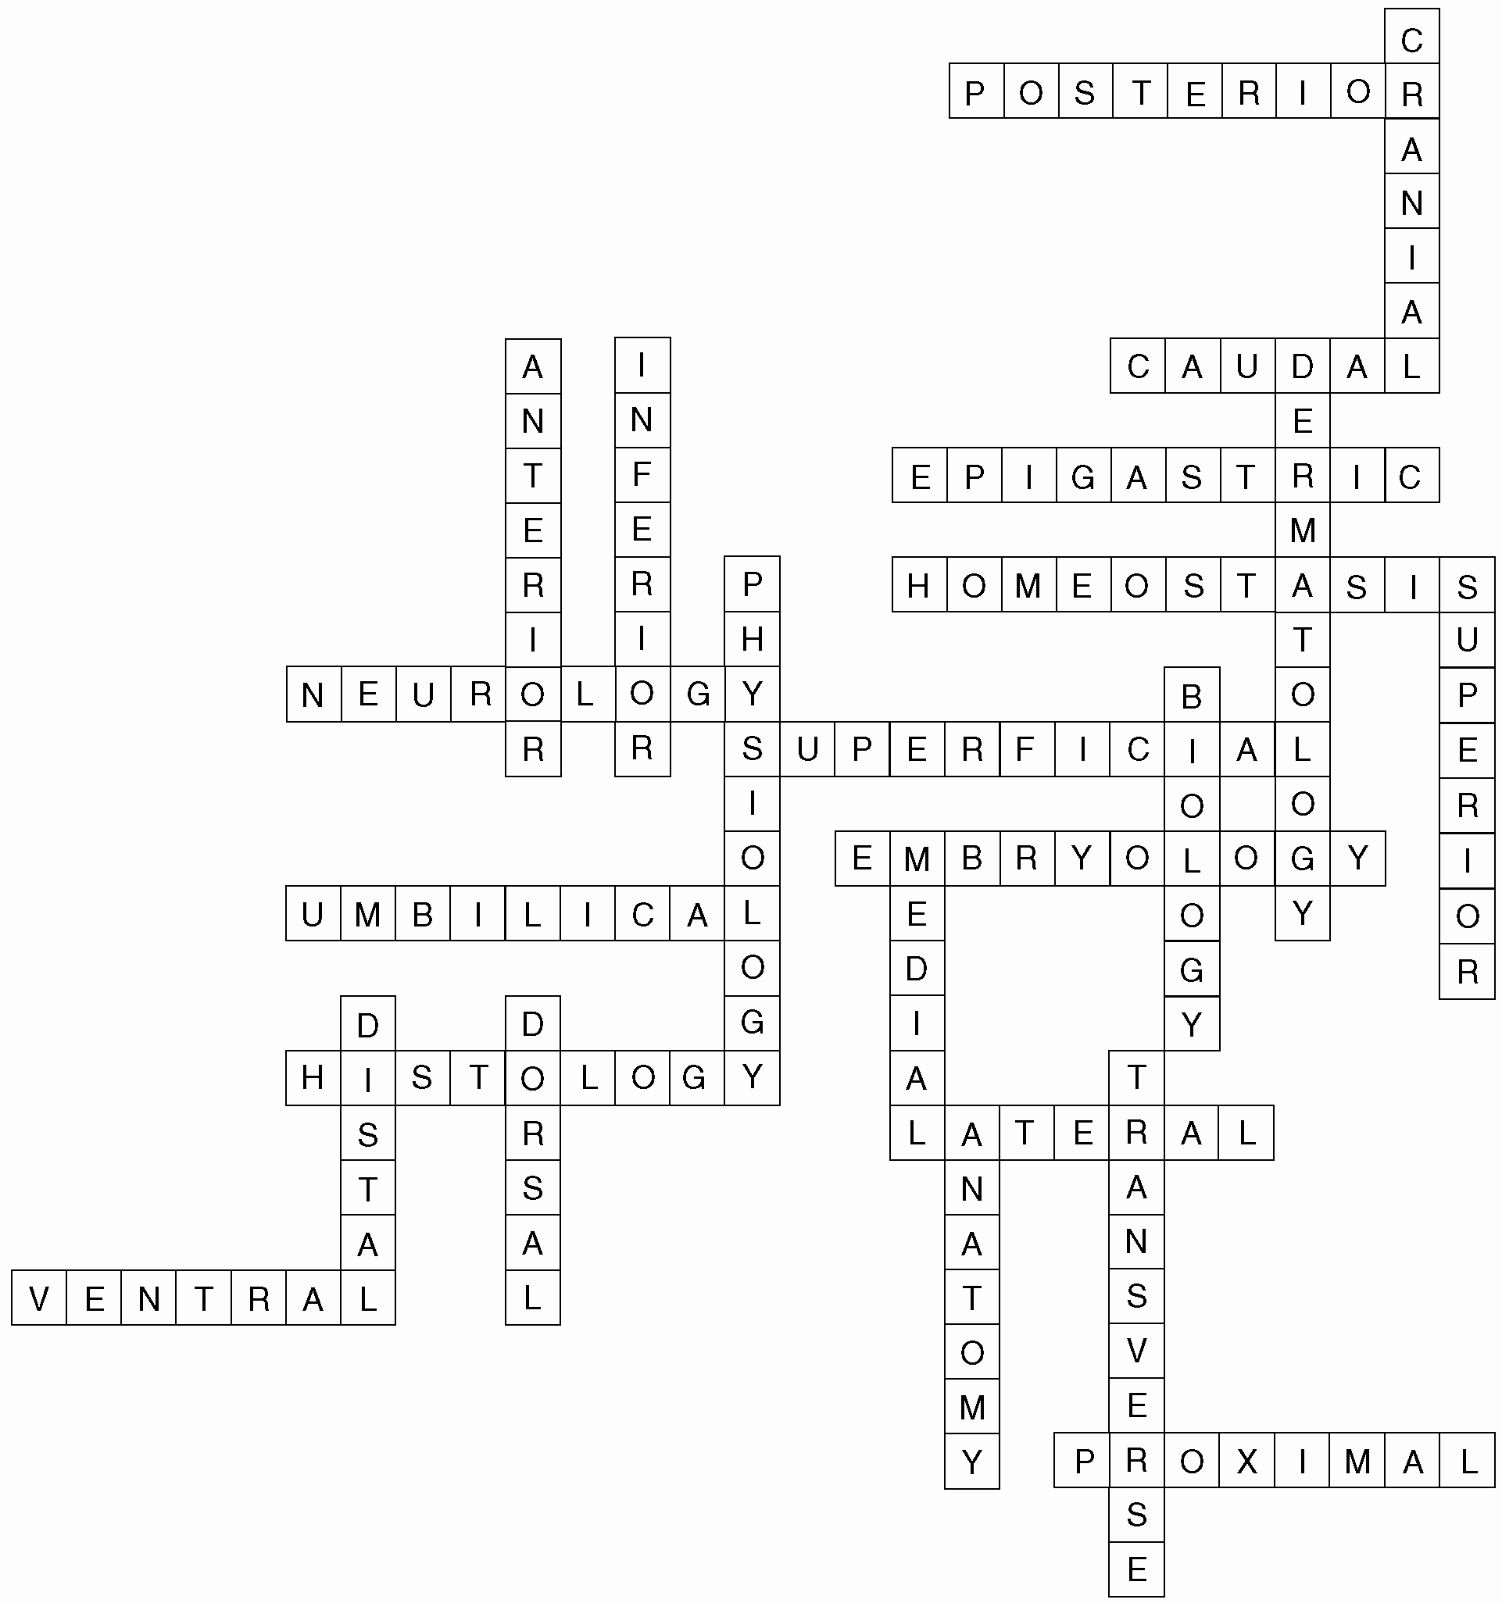
Surf the net
Surf the net to find additional information on the following:
- Body planes, directions, cavities and quadrants Body systems
- Body systems
- Electron microscope
- Homeostasis
- Medical imaging
- Metabolism
- Nanotechnology
Chapter 1

Introduction to the Structural Units
Overview
This chapter is an introduction to the study of the structure (anatomy) and function (physiology) of the body.
Anatomy and Physiology
Branches of Anatomy
Branches of anatomy subdivide the field and include gross, microscopic, developmental, comparative, and systematic anatomy.
Lecture on the different methods people use to study the body. In this textbook, the body is studied using the systematic method; in the study of pathology, microscopic anatomy is studied.
Have students examine their cheek cells using a microscope and, if possible, a phase-contrast microscope.
Materials needed: flat toothpicks, microscope slides, coverslip and microscope, pen, and paper. Students will
Step 1: Take a flat toothpick and gently scrape the inside of the mouth.
Step 2: Smear the saliva specimen on a flat microscope slide and cover the specimen with a coverslip.
Step 3: Examine the slide under the microscope. Draw what they see.
Step 4: Examine the slide under the phase-contrast microscope. Draw what they see.
Step 5: Wash hands and dispose of the material.

Question: “What were the major differences between what you saw using each microscope?” Pair and share information with classmates.
Internet search words: phase-contrast microscope.
Anatomic Terminology
Lecture on the use of correct terminology as it refers to the body and is used by all health care professionals.
Terms that relate to body direction include anterior/posterior, cranial/caudal, superior/inferior, medial/lateral, proximal/distal, and superficial/deep.
Use overhead projections to demonstrate how the terms are used as opposites.
Demonstrate the areas on class members.
Have the students think-pair-share this experience.
Body planes include sagittal, coronal, ventral, and transverse.
Lecture on how these terms are used as reference points in the body.
Show overhead projections of body planes.
Websites can assist in understanding directional terms and body planes.
Terminology of body cavities, regions, and quadrants serves as reference points in health care:
Dorsal: cranial and spinal cavities
Ventral: thoracic and abdominopelvic cavities
Use an anatomical model to demonstrate the areas discussed. Show the nine regions of the abdominopelvic cavity and its four quadrants on a PowerPoint slide or overhead.
Artifact strategy: Place the organs from the body cavities in a bag. Have the student pick up one organ and place it in the correct body cavity.

Anatomical Position
Demonstrate the anatomical position using a class member; stress this as the reference point for all anatomical descriptions.
Life Functions
Life functions are the necessary activities that allow living organs to grow and function. Lecture on how the body functions to sustain life.
Lecture on body processes, including metabolism and homeostasis.
Lecture on homeostasis and the importance of keeping the body in balance through negative and positive feedback to ensure regular body functions.
Have the students keep a 2-hour log for an assigned time period, then pair and share what occurred in the time period that may have affected their homeostasis.
Review and Class Activities
- Why is it so important to know anatomical terminology?
- Medical Highlights—Biotechnology and Nanotechnology: Group project—Students will search the Internet for the uses of biotechnology in medicine and the use of nanotechnology in medical devices.
Have students respond to the question: “What is the long-term goal of the National Institutes of Health regarding nanoparticles?”
- Homeostasis: Think-pair-share—What happens when the temperature falls outside? How does the body adjust?
- Metric system: Using a variety of measuring cups, demonstrate the comparison between household measurements and the metric system. Prepare a list of measurements, such as milliliters, grams, and liters. Have students investigate and write down equivalents from their own household items.
Answers to Chapter Quiz
The quiz can be found at the end of the chapter in this manual.
1. Physiology—all other terms are types of anatomy.
2. Coronal—all other terms are directional.
3. Medial—all other terms relate to the surface of the body.
4. Heart—all other terms relate to the abdominopelvic cavity of the body.
5. Caudal—all other terms refer to sections or planes of the body.
6. Thoracic—all other terms relate to the nine regions of the abdominal area.
7. Growth—all other terms are processes of digestion.
8. Physiology—all other terms relate to special life functions.
9. Nose—all other terms relate to the organs in the orbital cavity.
10. Homeostasis—all other terms relate to the process of metabolism.
Chapter Quiz

Name ___________ Date __________ Instructor ____________
Circle the word or words that do not belong to each group.
1. Microscopic, systematic, comparative, physiology
2. Anterior, superior, coronal, cranial
3. Medial, superficial, deep, external
4. Heart, gallbladder, pancreas, spleen
5. Coronal, sagittal, caudal, transverse
6. Hypogastric, thoracic, umbilical, epigastric
7. Ingestion, growth, synthesis, assimilation
8. Movement, transport, physiology, excretion
9. Eyes, nose, optic nerve, tear ducts
10. Metabolism, anabolism, catabolism, homeostasis

